# **Jane Tho’ra** - Proto FusionGirl

###### **Codename: “Jane Tho’ra” (The Proto FusionGirl)**

#### **Holo Test Pilot**

##### Psi Operator

##### **Base Gear**

##### **Psionic Defenses**

##### **Magneto Repulsors**

##### **Holo Projectors**

##### **Core Gear**

##### **Fusion Wings**

##### **Star Morphers**

##### **Warp Cores**

##### **Support Gear**

##### **Magneto Speeders**

##### **Drop Pods**

##### **Pop Cells**

##### **Battle Gear**

##### **Super Blades**

##### **Hyper Drives**

##### **Ultra Shields**

# Fusion Wings

## Psi-Tech Trans-Dimensional Rift Stabilizers - with Sparkle Flairs

Various Fusion Wings with Dimensional Projectors and Psi Blades *(includes Mirage Field)*

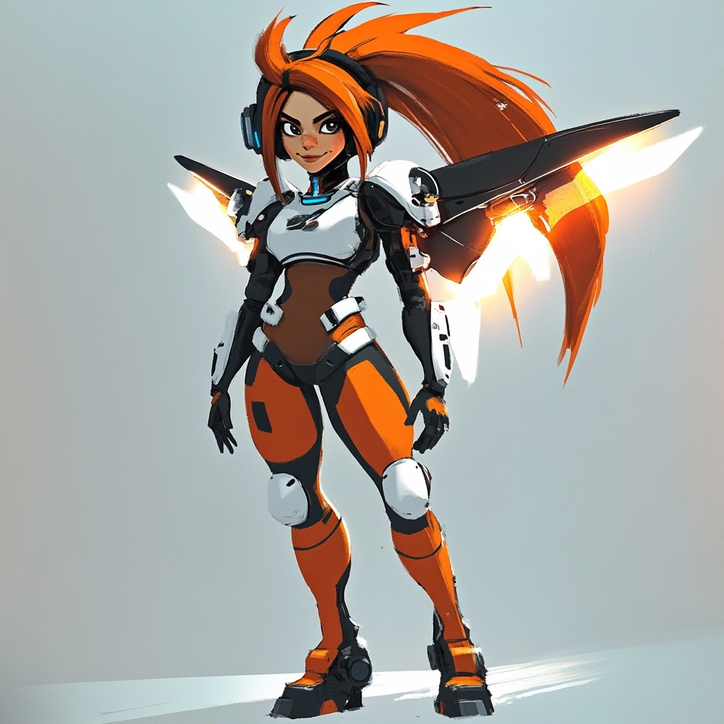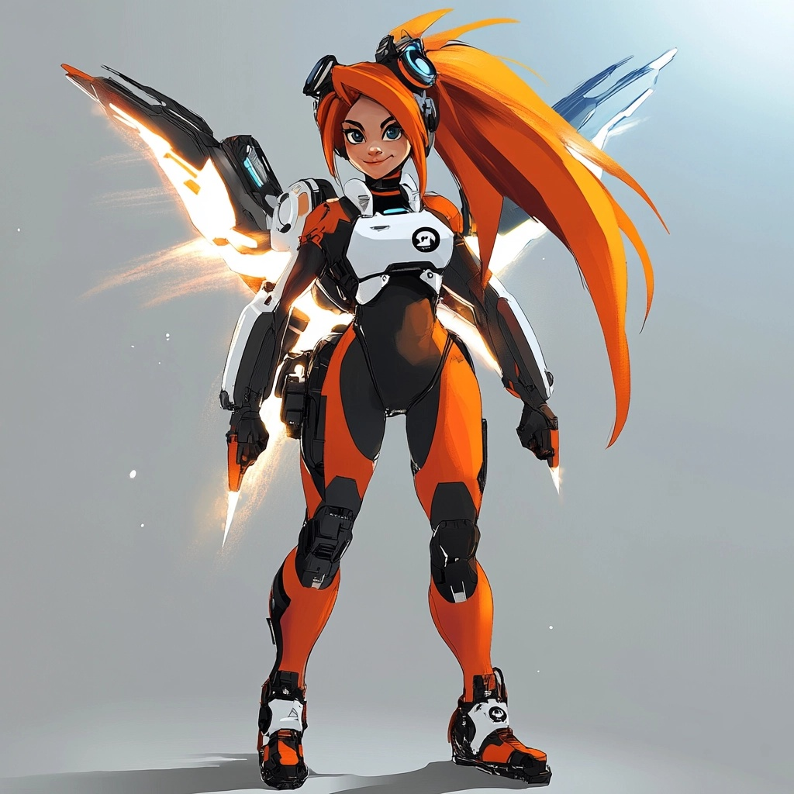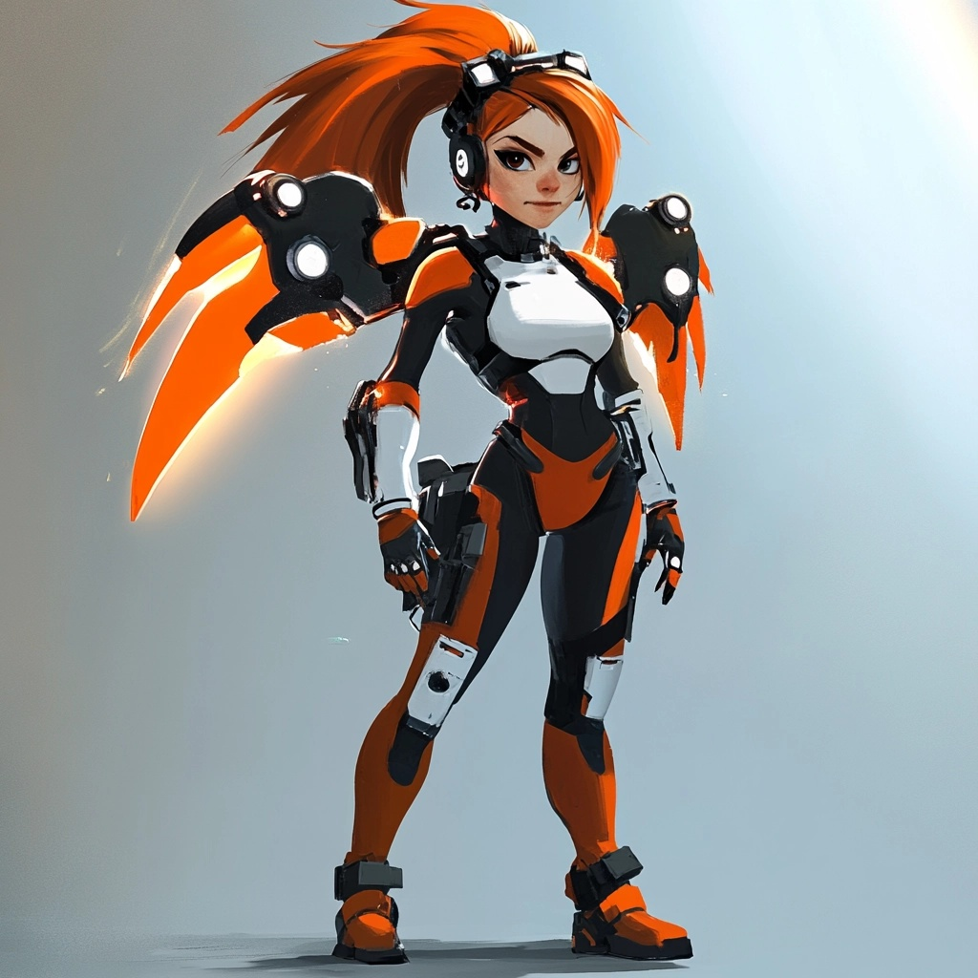

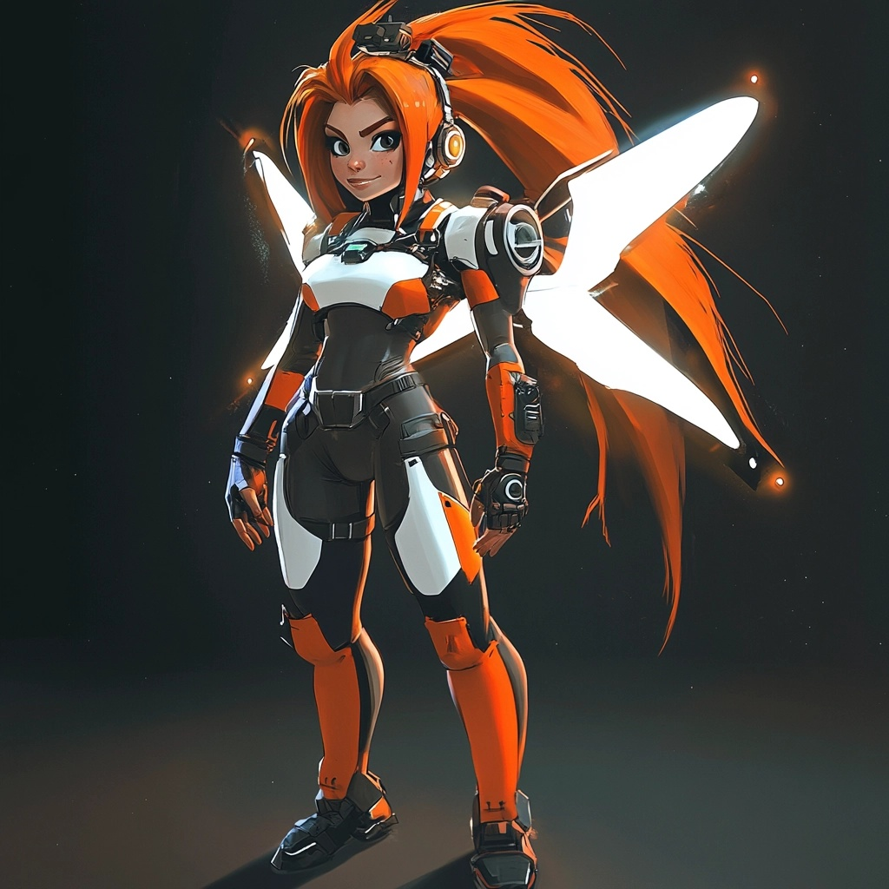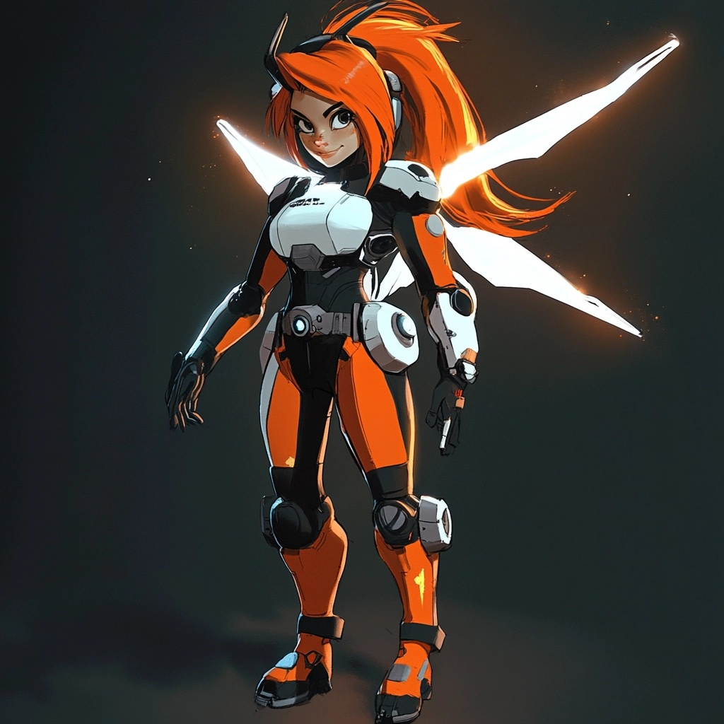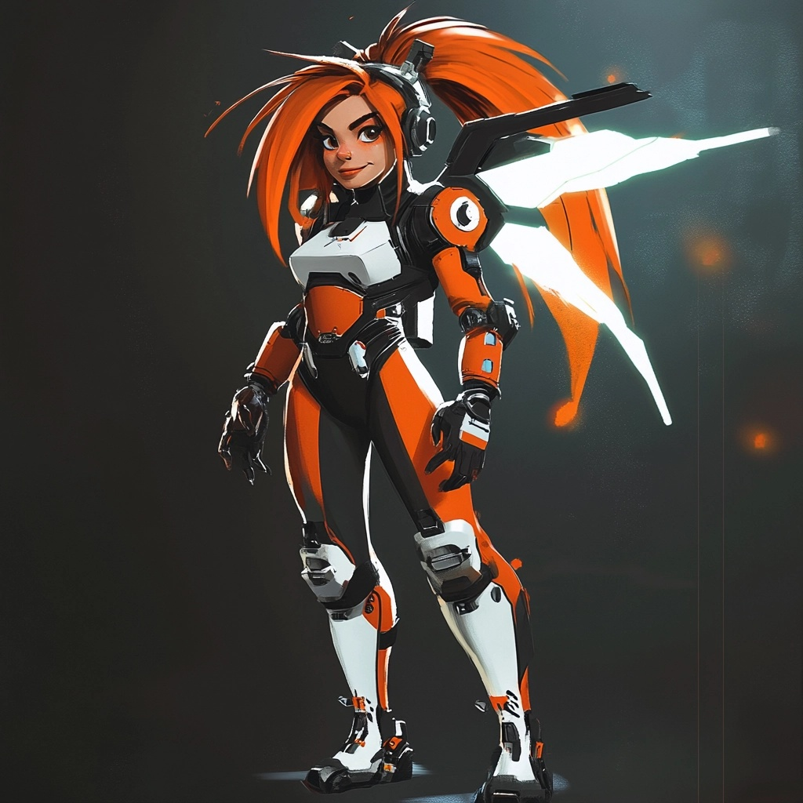

#### FusionGirl - **Fusion Wing Projection Kit** (Core Gear)

* **Psi Blades** form from behind as **Blade Weapons** and **Energy Reservoirs**!

###### Cold Fusion is part of the process of sustaining the wings at Idle.

* **Dimensional Projectors** allow the wings to become **Time Anchors**!

###### The Fusion Wings are be used to close Dimensional Rifts.

# HelmKit

## PsiNet UpLink Headsets *(now with Electrostatic Hair Styling!)*

Various Psi Shields with different Psi Stabilizers and Defense Discs *(standard with PsiNet UpLink!)*

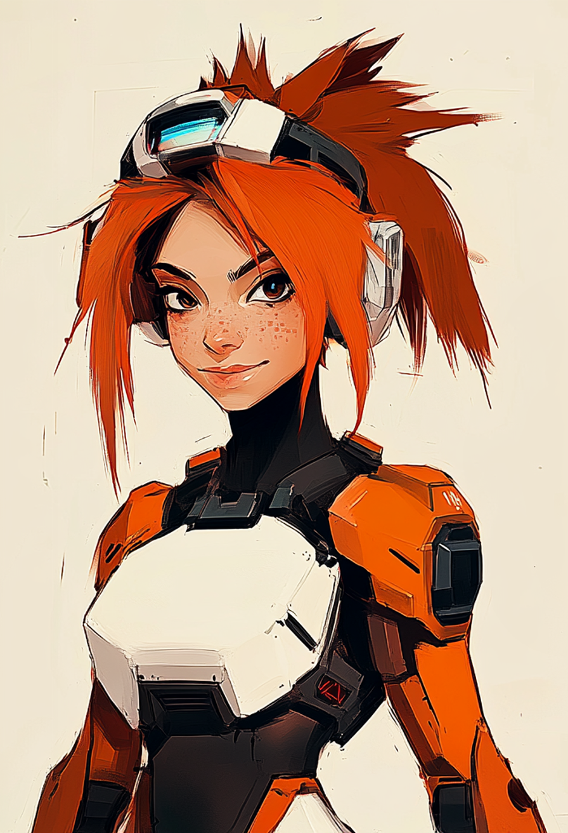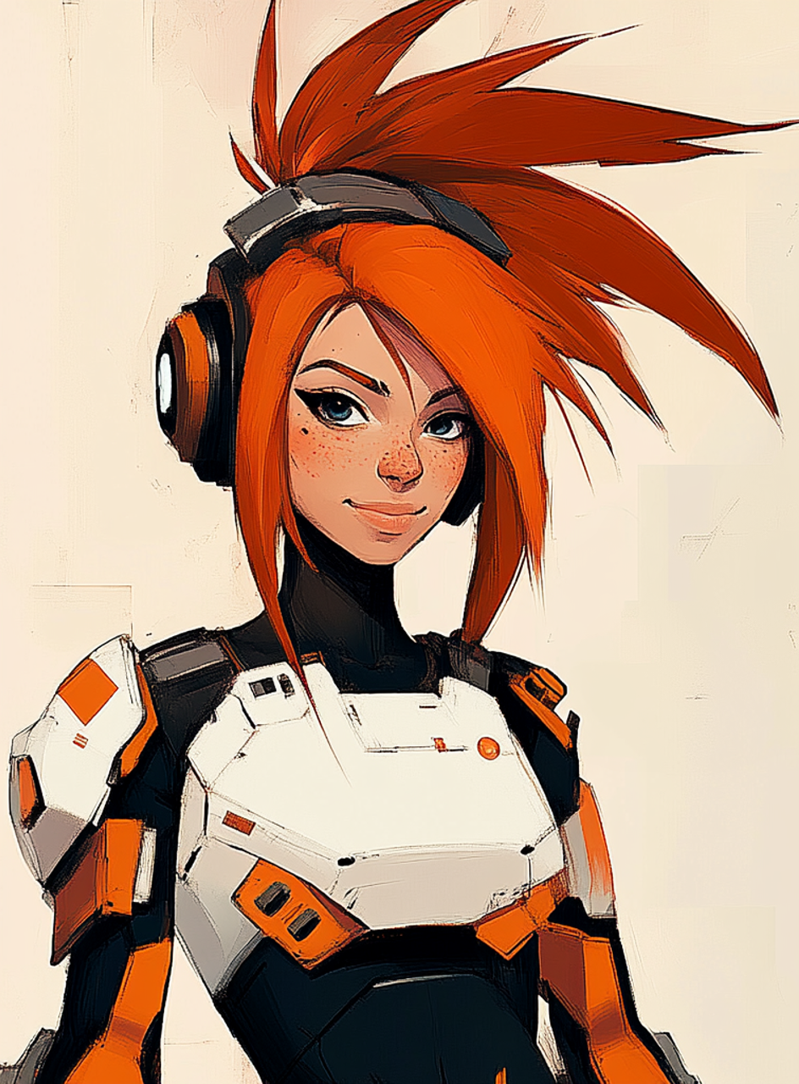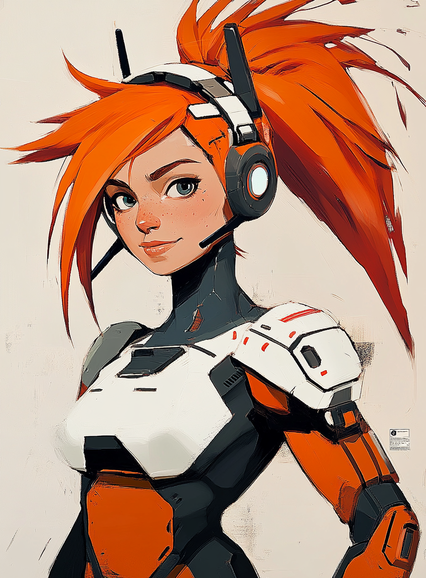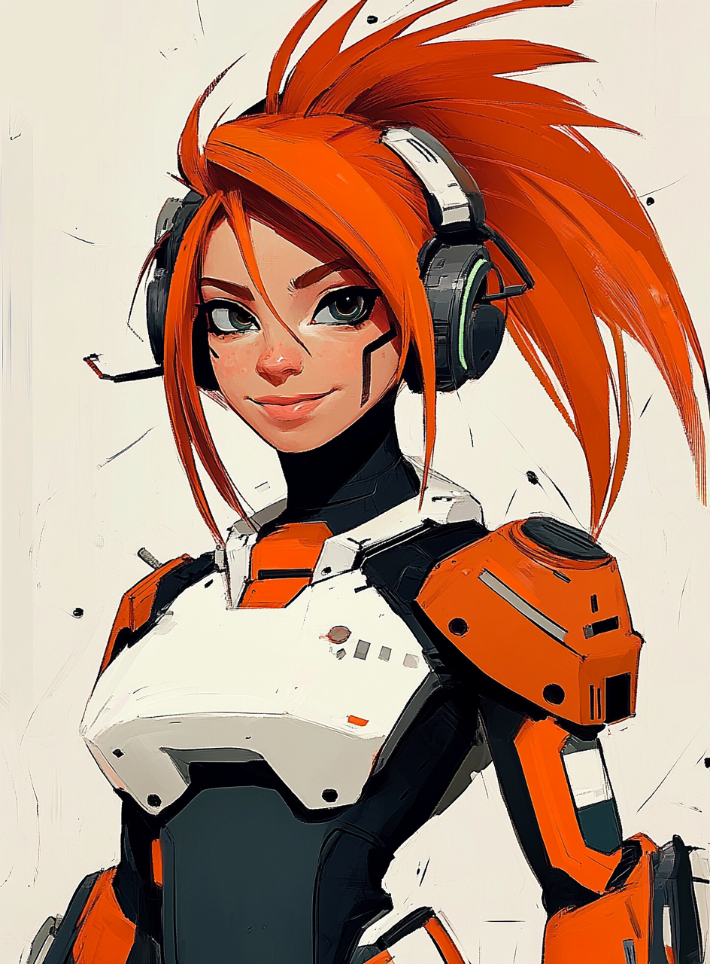

FusionGirl’s Hair can be Electrostatically charged positively with anti-lightning ion flux fields.

* Human Hair is used as a natural part of the Psi Defense Field: creating wild hair styles!
  + These hair styles are really just the hair naturally falling into electrostatic pockets.
* Long Human Hair becomes a fine-tuned and high-performance Psionic Antenna.

# Archangel Agency Intel Document

## Jane Tho’ra - Proto FusionGirl

### Introduction

**Name:** Jane Tho’ra

**Codename:** Proto FusionGirl

**Role:** Holo Test Pilot, Psi Operator

**Primary Objective:** Save the world as a PsiOps Superhero by stabilizing interdimensional rifts, combating cosmic threats, and navigating complex multiverse realities.

#### Personality:

* **Determined:** Despite her “average” self-perception, Jane is highly adaptable and resourceful.
* **Empathetic:** Jane forms deep emotional connections with allies, robots, and even sentient universes.
* **Curious:** Her innate curiosity fuels her mastery of Universal Language and advanced psionic techniques.

### Core Identity

#### Background:

* A gifted Holo Test Pilot with latent Psi abilities, Jane joins the PsiOps program, where she discovers her pivotal role in the multiverse.
* Guided by her mentor, Jono Tho’ra, she embarks on a journey to uncover Universal Language and its cosmic significance.
* Balances her “everyday girl” charm with the responsibilities of being humanity’s last hope.

#### Skills and Special Abilities:

* **Universal Language Mastery:** Enables her to reprogram reality using psionic logic and Universal Magic.
* **Psionic Aptitude:** Exceptional skill in manipulating energy fields and mental projections.
* **Pilot Expertise:** Proficient in operating advanced vehicles like the Magneto Speeder and Drop Pods.

# Gear Overview

## Base Gear

* **Psionic Defenses:** Shields her against physical, mental, and energy-based threats.
* **Magneto Repulsors:** Grants limited levitation and propulsion in combat scenarios.
* **Holo Projectors:** Projects decoys, illusions, and tactical overlays during missions.

## Core Gear

* **Fusion Wings:**
  + Psi-Tech Trans-Dimensional Rift Stabilizers with Sparkle Flairs.
  + Cold Fusion maintains stability at idle, enhancing durability.
* **Dimensional Projectors:** Time Anchors allow precise navigation of timestreams.
  + Psi Blades extend for offense, doubling as energy reservoirs.
  + Essential for closing dimensional rifts.
* **Star Morphers:** Compact tools capable of morphing into advanced psionic devices, robot companions, combat mecha and full body hyper suits.
* **Warp Cores:** Enables small-scale space-time manipulations for tactical advantages.

## Support Gear

* **Magneto Speeders:** High-speed exocraft designed for Ley Line navigation.
* **Drop Pods:** Tactical deployment modules for rapid insertion into hostile environments.
* **Pop Cells:** Modular energy containers for on-the-go power replenishment.

## Battle Gear

* **Super Blades:** Psi-charged melee weapons with adaptive capabilities.
* **Hyper Drives:** Grants temporary boosts to movement speed and evasion.
* **Ultra Shields:** Advanced defensive systems combining psionic fields and kinetic barriers.

# Specialized Gear: Fusion Wings

* **Description:** A signature tool in Jane’s arsenal, Fusion Wings are multifunctional psionic devices. All Tho’ra are equipped with Fusion Wings, thanks to and including Jono Tho’ra.
  + **Features:**
    - **Psi Blades:** Function as both offensive tools and energy conduits.
    - **Time Anchors:** Stabilize surrounding timelines during interdimensional rift closures.
    - **Dimensional Projection:** Allows phased visibility and stealth operations.

# Psi-Tech Enhancements

## HelmKit

* **PsiNet Uplink Headsets:**
  + Real-time connection to the PsiNet, enabling enhanced situational awareness.
  + Electrostatic hair styling integrates Jane’s hair as a natural Psionic Antenna.
* **Defense Discs:**
  + **Psi Shields:** Tailored for specific threats (physical, mental, energy).
  + **Stabilizers:** Balances psionic fields during high-energy operations.

## Hair as Psionic Antenna

* **Functionality:**
  + Human hair naturally falls into electrostatic pockets, creating wild, dynamic hairstyles.
  + Acts as a high-performance psionic receptor for amplifying Universal Language abilities.

# Character Development and Emotional Depth

## Motivations:

* **Personal Growth:** Jane evolves from an “average girl” to a multidimensional hero.
* **Connection:** Forms meaningful relationships with allies, including sentient robots and alternate versions of herself.
* **Mission:** Balances personal challenges with her cosmic duty to save the world and stabilize the timestream.

## Key Relationships:

* **Jono Tho’ra:** Mentor and guide who provides wisdom, tactical advice, and emotional support.
* **PsiSys:** Collective of Psionic Robots that aid Jane in missions, often reflecting her emotional state.
* **FusionGirl Variants:** Alternate-reality versions of Jane, showcasing different aspects of her potential.

# Combat and Tactical Skills

## Combat Style:

* **Psionic Combat:** Uses energy manipulation and mental projections to disarm or incapacitate foes.
* **Versatility:** Balances melee (Psi Blades) and ranged (Fusion Wing projectiles) combat.
* **Adaptability:** Incorporates environment and gear into tactical strategies.

## Tactical Mastery:

* **Resource Management:** Efficiently utilizes Pop Cells and Drop Pods in high-stakes scenarios.
* **Team Coordination:** Commands allies, robots, and factions with precision and empathy.

# Narrative Integration

## Role in FusionGirl Universe:

* **Proto FusionGirl:** Serves as the foundational character for the larger FusionGirl saga.
* **Universal Language Pioneer:** Jane’s mastery of Universal Language bridges gameplay mechanics and narrative progression.
* **Cosmic Savior:** Represents hope, unity, and the infinite potential of an average person guided by extraordinary circumstances.

## Story Highlights:

* **Discovery of Universal Language:** Marks Jane’s transition from self-doubt to cosmic confidence.
* **Confrontation with the Draken Seforthi:** Highlights her courage and ability to face overwhelming odds.
* **Stabilizing Timestreams:** Emphasizes her technical and emotional growth as she navigates the multiverse.

# Cosmetic and Customization Options

## In-Game Customizations:

* **Fusion Wings:** Skins, patterns, and visual effects tailored to player preferences.
* **Outfits:** From tactical suits to ceremonial PsiNet robes, each reflecting gameplay milestones.
* **Hair Styles:** Dynamic electrostatic designs based on psionic energy flow.

## Collectible Cosmetics:

* Event-specific skins, Magneto Speeder designs, and unique Psi Blade patterns.

#### Legacy

Jane Tho’ra is more than a character—she is the heart of FusionGirl. Her journey reflects the power of growth, determination, and the universal magic within every individual. By mastering Universal Language, she not only redefines the multiverse but also empowers players to embrace their potential and change their own worlds.